Program 1:

//Program to check if a person is eligible for voting or not

include<stdio.h>
int main(){
int age;
printf("Enter your age: ");
scanf("%d",&age);
if(age>=18)
printf("\nYou are eligile to vote.\n");
else
printf("\nYou are not eligible to vote\n");
}

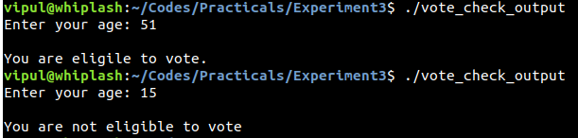

Program 2:

//Program to check if alphabet entered is a vowel or a constant

#include<stdio.h>
int main(){
char c;
printf("Enter an alphabet: ");
scanf("%c",&c);
if(c=='a' || c=='e' || c=='i' || c=='o' || c=='u' || c=='A' || c=='E' |$
printf("\n%c is a vowel.\n",c);
else
printf("\n%c is a consonant\n",c);
}

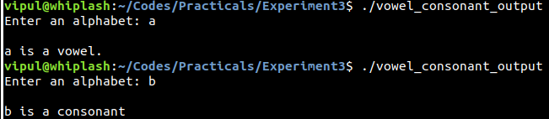

Program 3:

//Program to check if the number is greater than 100 and even

#include<stdio.h>
int main(){
int num;
printf("Enter a number: ");
scanf("%d",&num);
if(num>100 && num%2==0)
printf("\n%d is greater than 100 and even.\n",num);
else
printf("\n%d does not satisy given condition.\n",num);
}

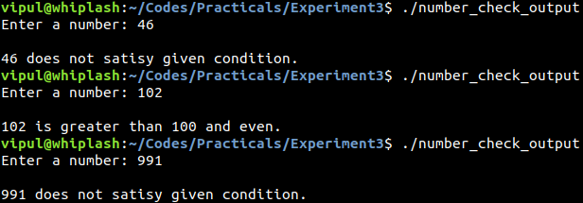

Program 4:

//Program to check if a person senior citizen and male

#include<stdio.h>
int main(){
int age;
char gender;
printf("Enter your age and gender:\n");
scanf("%d %c",&age,&gender);
if(age>=60 && (gender=='m' || gender=='M') )
printf("\nYou are a male senior citizen\n");
else
printf("\nYou do not satisy the given conditions\n");
}

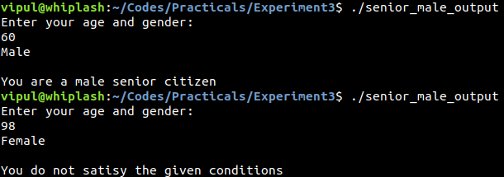

Program 5:

//Program to find smaller of two numbers using conditional operator

#include<stdio.h>
int main(){
int num1,num2,smaller;
printf("Enter two numbers:\n");
scanf("%d %d",&num1,&num2);
smaller=(num1<num2?num1:num2);
printf("\nThe smallest number is %d\n",smaller);
}

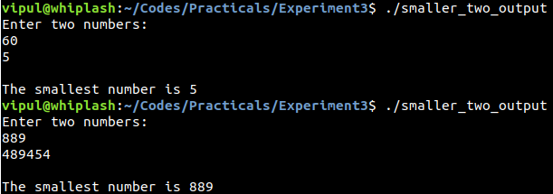

Program 6:

//Program to find greater of three number using conditional operator

#include<stdio.h>
int main(){
int a,b,c,greatest;
printf("Enter three numbers:\n");
scanf("%d %d %d",&a,&b,&c);
greatest=( (a>b)?( (a>c)?a:c):( (b>c)?b:c) );
printf("\n%d is the greatest number.\n",greatest);
}

